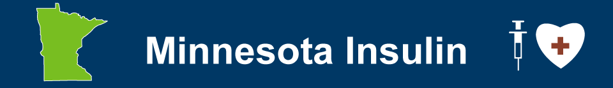

Sample Social Media

Text
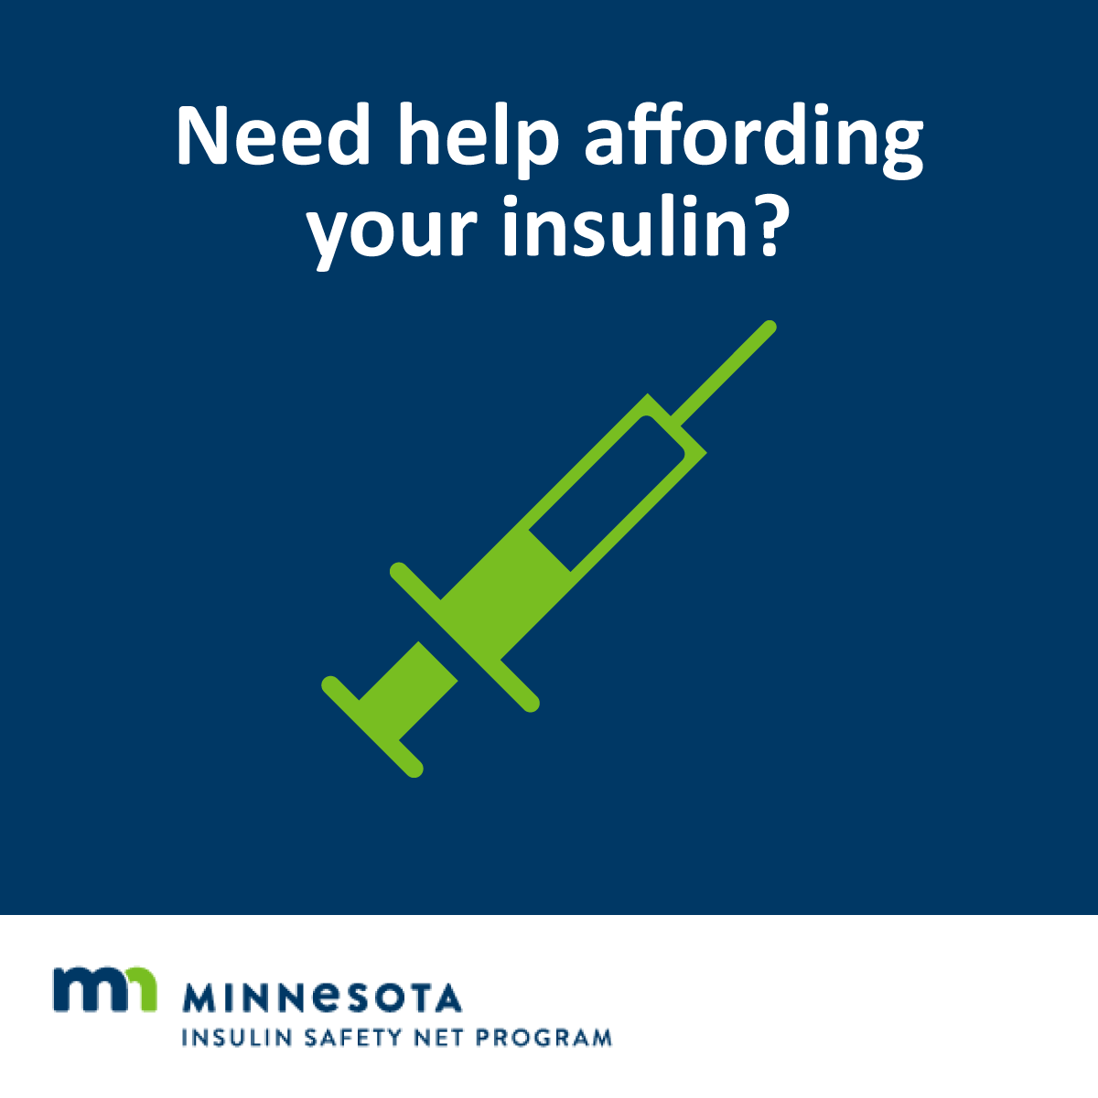
If you live in Minnesota and have an urgent need for insulin, you may qualify for the Minnesota Insulin Safety Net program. Learn more at MNinsulin.org. We can help if you have a continuing need for affordable insulin: [CONTACT INFO/LINK]


No one should have to ration their insulin. If you are in that situation, there’s help. Go to MNinsulin.org to find out more. Questions? We’re here to help! [CONTACT INFO/LINK]

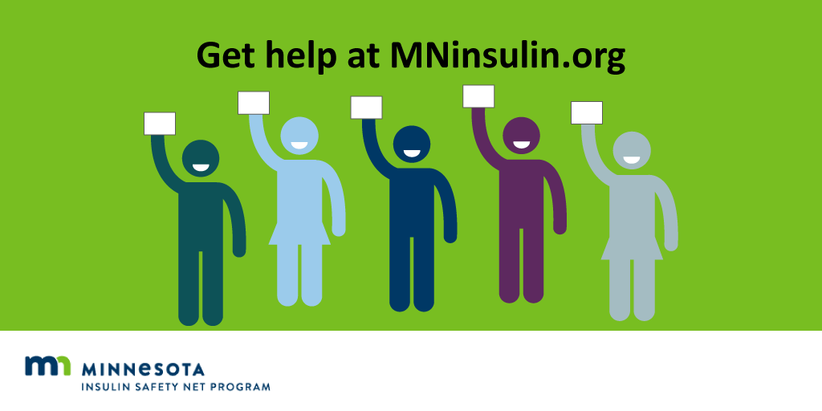
If you find yourself running low on insulin, the MN Insulin Safety Net program may be able to help. Visit MNinsulin.org, download the application, fill it out & take the form to your pharmacy (with ID & insulin prescription).


If you have a continuing need for insulin, contact us. We’re trained to help Minnesotans sign up for the MN Insulin Safety Net Program & insulin manufacturer patient assistance programs. Reach us at [LINK/CONTACT INFO]

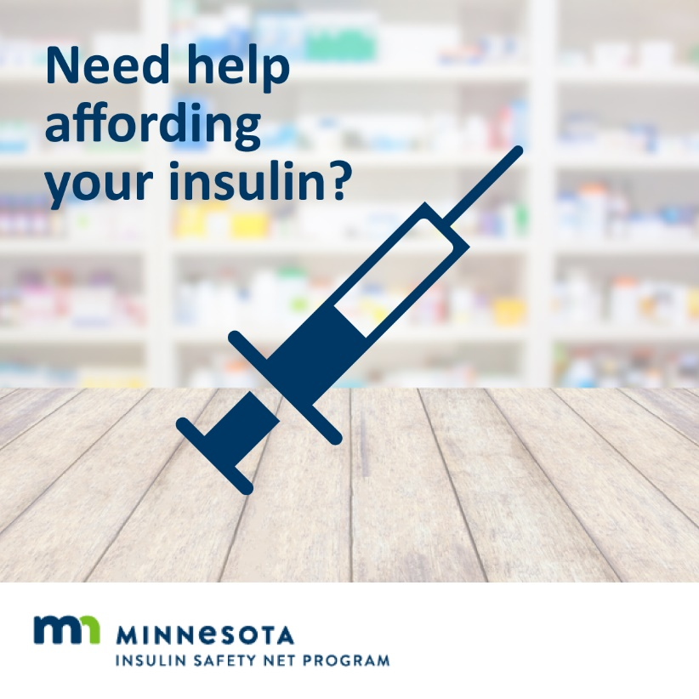
Minnesotans in urgent need of insulin (<7-day supply on hand) can apply for the Minnesota Insulin Safety Net Program starting on July 1, 2020. Learn more at MNinsulin.org.

